**INSTALLATION TOOLS:**

1.INSTALL MYSQL, VISUAL STUDIO CODE, PYTHON.

2.IN CMD OR VSCODE TERMINAL ENTER “pip install mysql-connector-python”.

**MYSQL WORKBENCH OR WINDOWS CMD TUTORIAL:**

1.Enter Command **mysql – u root -p.**

2.Enter the password.

3.Then Type “show databases;” and Enter.

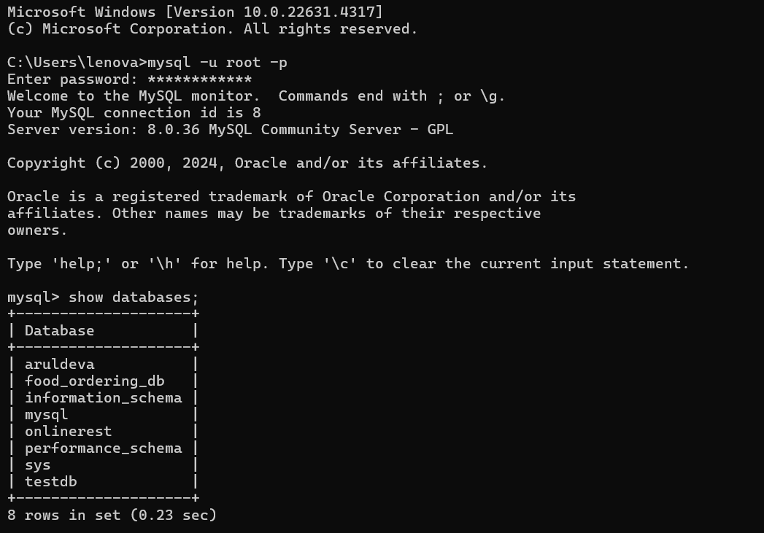

.

1.To Create your database.

2.**CREATE DATABASE FOOD MONITORING;**

3.Then type “SHOW DATABASES” to view your created database.

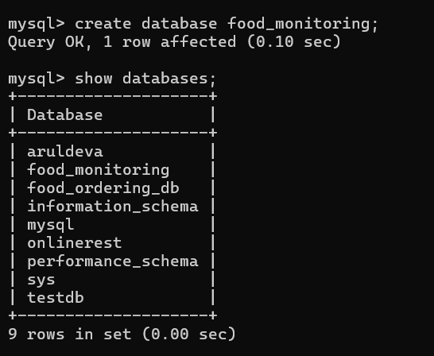

1.Type command **“SELECT * FROM food_items;”**

2. Then type this Query

**CREATE TABLE IF NOT EXISTS food_items (**

**id INT AUTO_INCREMENT PRIMARY KEY,**

**name VARCHAR(100),**

**quantity INT,**

**expiry_date DATE**

**);**

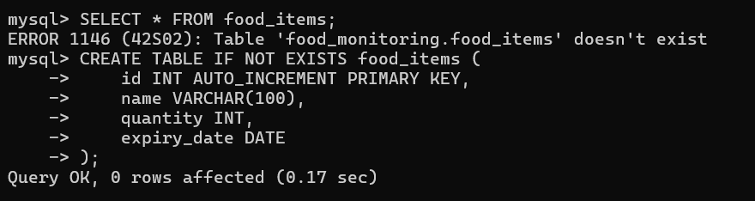

1.Then Type Show Tables;(check your table found).

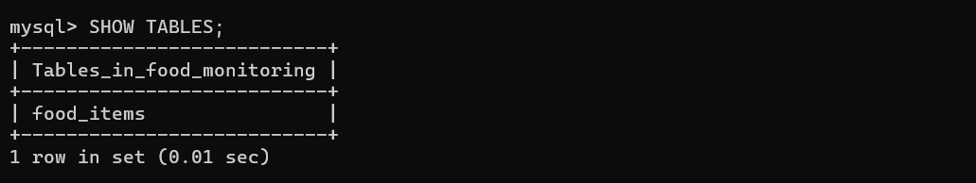

1.Then type the insert query to view as Table.

**INSERT INTO food_items (name, quantity, expiry_date) VALUES ('Apples', 10, '2024-10-25');**

**INSERT INTO food_items (name, quantity, expiry_date) VALUES ('Bread', 5, '2024-10-20');**

2.After completed use the below command to view your data as table.

**SELECT * FROM food_items;**

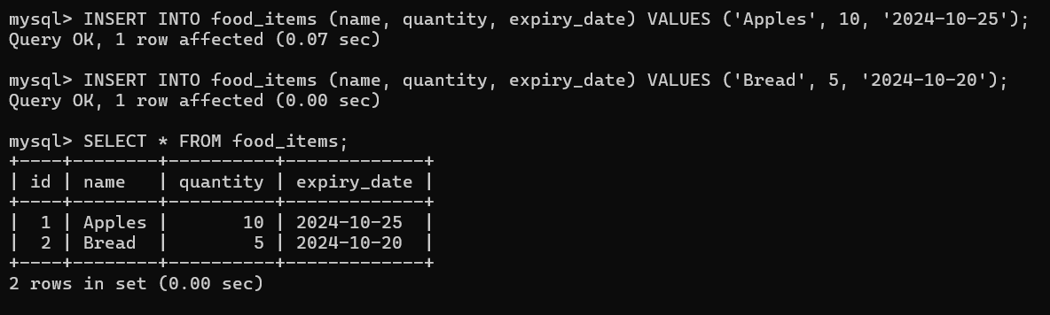

**SAMPLE OUTPUT:**

